**NAME: SUVIDHI V. PAREEK  
  
SE(COMPS) / DIV-3 / ROLL NO-10**

**Experiment no 5**

**Aim:**

**To implement Circular Queue ADT using array**

**Objective:**

**Circular Queue offer a quick and clean way to store FIFO data with maximum size**

**Theory:**

**A Circular queue is a linear data structure where the first index comes right after the last index assuming indices are attached in a circular manner.**

**Circular Queue works by the process of circular increment i.e. when we try to increment the pointer and we reach the end of the queue, we start from the beginning of the queue.**

**A circular queue is the extended version of a** [**regular queue**](https://www.programiz.com/data-structures/queue) **where the last element is connected to the first element. Thus forming a circle-like structure.**

**Algorithm:**

**Algorithm to insert an element in Circular Queue**

**Step 1: IF FRONT = 0 and Rear = MAX - 1**

**Write "OVERFLOW"**

**Goto step 4**

**[End OF IF]**

**Step 2: IF FRONT = -1 and REAR = -1**

**SET FRONT = REAR = 0**

**ELSE IF REAR = MAX - 1 and FRONT != 0**

**SET REAR = 0**

**ELSE**

**SET REAR = REAR + 1**

**[END OF IF]**

**Step 3: SET QUEUE [REAR] = VAL**

**Step 4: EXIT**

**Deleting an element from Circular Queue**

**Step 1: IF FRONT = -1**

**Write “UNDERFLOW”**

**Goto Step 4**

**[END of IF]**

**Step 2: SET VAL= QUEUE[FRONT]**

**Step 3: IF FRONT = REAR**

**SET FRONT = REAR = -1**

**ELSE**

**IF FRONT = MAX -1**

**SET FRONT = 0**

**ELSE**

**SET FRONT = FRONT + 1**

**[END of IF]**

**Step 4: EXIT**

**Circular Queue implementation in C**

**#include <stdio.h>**

**#define SIZE 5**

**int items[SIZE];**

**int front = -1, rear = -1;**

**// Check if the queue is full**

**int isFull() {**

**if ((front == rear + 1) || (front == 0 && rear == SIZE - 1)) return 1;**

**return 0;**

**}**

**// Check if the queue is empty**

**int isEmpty() {**

**if (front == -1) return 1;**

**return 0;**

**}**

**// Adding an element**

**void enQueue(int element) {**

**if (isFull())**

**printf("\n Queue is full!! \n");**

**else {**

**if (front == -1) front = 0;**

**rear = (rear + 1) % SIZE;**

**items[rear] = element;**

**printf("\n Inserted -> %d", element);**

**}**

**}**

**// Removing an element**

**int deQueue() {**

**int element;**

**if (isEmpty()) {**

**printf("\n Queue is empty !! \n");**

**return (-1);**

**} else {**

**element = items[front];**

**if (front == rear) {**

**front = -1;**

**rear = -1;**

**}**

**// Q has only one element, so we reset the**

**// queue after dequeing it. ?**

**else {**

**front = (front + 1) % SIZE;**

**}**

**printf("\n Deleted element -> %d \n", element);**

**return (element);**

**}**

**}**

**// Display the queue**

**void display() {**

**int i;**

**if (isEmpty())**

**printf(" \n Empty Queue\n");**

**else {**

**printf("\n Front -> %d ", front);**

**printf("\n Items -> ");**

**for (i = front; i != rear; i = (i + 1) % SIZE) {**

**printf("%d ", items[i]);**

**}**

**printf("%d ", items[i]);**

**printf("\n Rear -> %d \n", rear);**

**}**

**}**

**int main() {**

**// Fails because front = -1**

**deQueue();**

**enQueue(10);**

**enQueue(14);**

**enQueue(6);**

**enQueue(4);**

**enQueue(8);**

**// Fails to enqueue because front == 0 && rear == SIZE - 1**

**enQueue(6);**

**display();**

**deQueue();**

**display();**

**enQueue(9);**

**display();**

**// Fails to enqueue because front == rear + 1**

**enQueue(8);**

**return 0;**

**}**

**OUTPUT:**

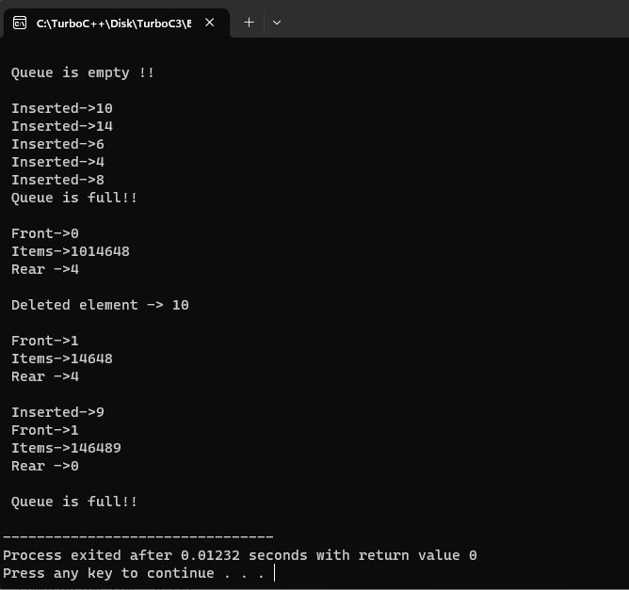

**CONCLUSION:**

**The circular queue solves the major limitation of the normal queue. In a normal queue, after a bit of insertion and deletion, there will be non-usable empty space.**